**DAILY ONLINE ACTIVITIES SUMMARY**

|  |  |  |  |  |  |  |  |  |
| --- | --- | --- | --- | --- | --- | --- | --- | --- |
| **Date:** | 12-06-2020 | | | | | **Name:** | SINDHU N | |
| **Sem & Sec** | 6th and B | | | | | **USN:** | 4AL17CS094 | |
| **Online Test Summary** | | | | | | | | |
| **Subject** | | __ | | | | | | |
| **Max. Marks** | | __ | | **Score** | | | __ | |
| **Certification Course Summary** | | | | | | | | |
| **Course** | INTRODUCTION TO ETHICAL HACKING | | | | | | | |
| **Certificate Provider** | | | GREATLEARNINGACADEMY | | **Duration** | | | 1 WEEK |
| **Coding Challenges** | | | | | | | | |
| **Problem Statement:** GIVEN 3 PROBLEMS | | | | | | | | |
| **Status:** Completed | | | | | | | | |
| **Uploaded the report in Github** | | | | | Yes | | | |
| **If yes Repository name** | | | | | https://github.com/lsindhungowda/Daily-report | | | |
| **Uploaded the report in slack** | | | | | Sindhu N  Yes, I uploaded the report in slack | | | |

**SNAPSHOT OF ONLINE CERTIFICATION COURSE:**

**SCREENSHOT1:**

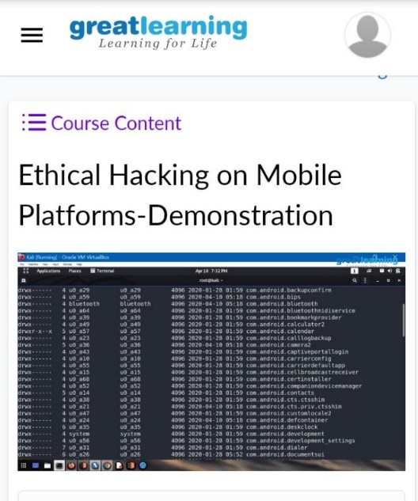

**SCREENSHOT2:**

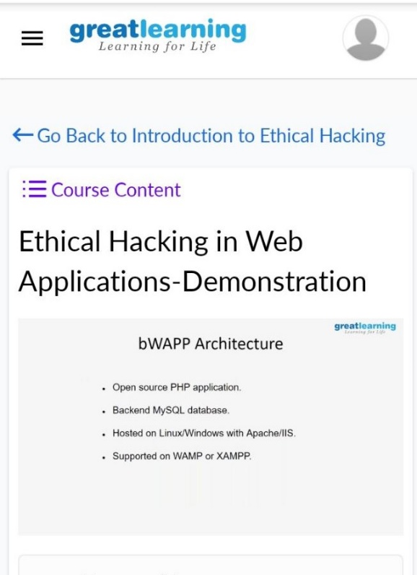

**SNAPSHOT OF ONLINE CODING:**

**PYTHON PROGRAM 1:**

**Python program to Count the Number of Vowels Present in a String using Sets Step1: Get a string Step2: find the no of occurrence of all vowels in the string using data structure set.**

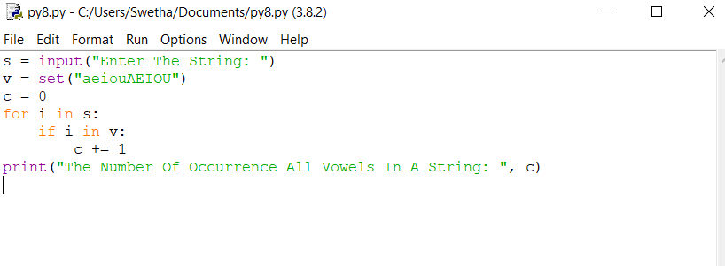

**OUTPUT:**

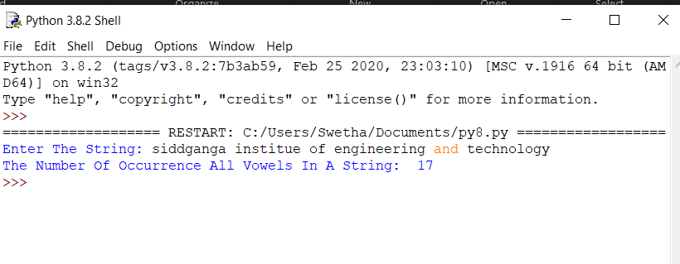

**PYTHON PROGRAM 2:**

**Write a python program to print the pattern for n value.**

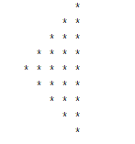

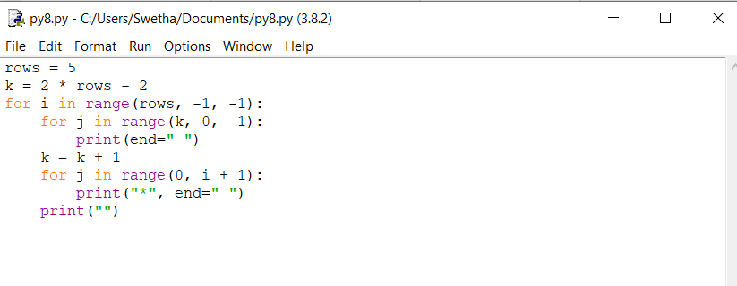

**OUTPUT:**

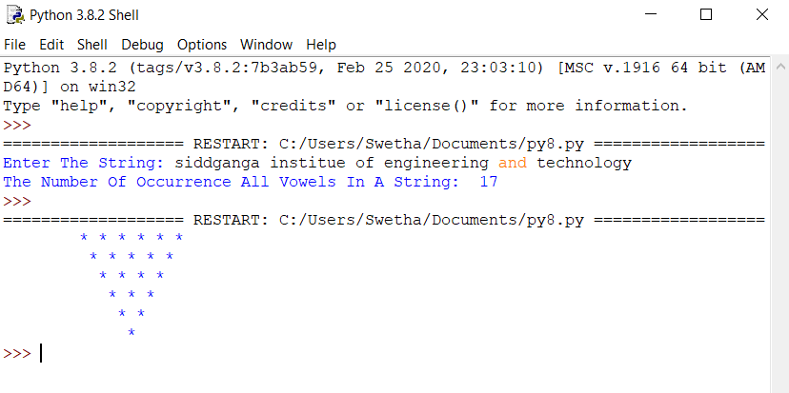

**PYTHON PROGRAM 3:**

**A magic square of order n is an arrangement of n^2 numbers, usually distinct integers, in a square, such that the n numbers in all rows, all columns, and both diagonals sum to the same constant. A magic square contains the integers from 1 to n^2.**

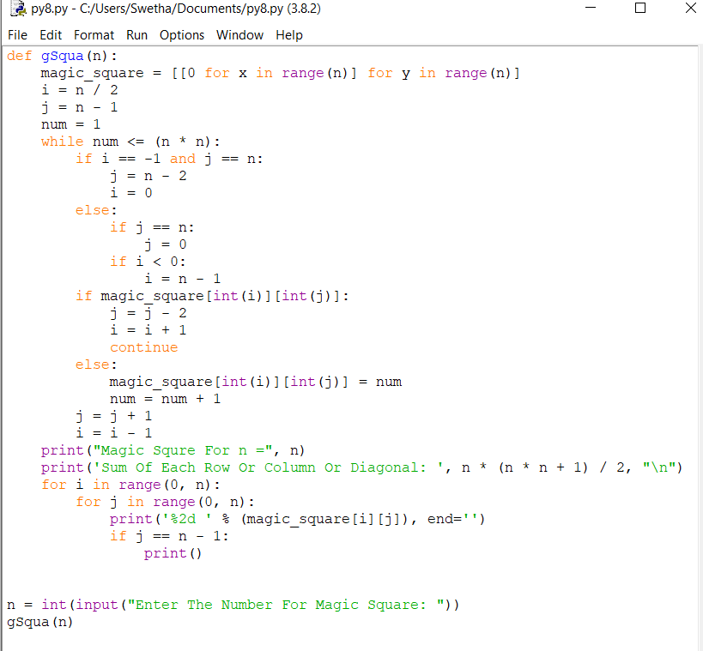

**OUTPUT:**

